Python Programming Language
Built-in Data Types
In programming, data type is an important concept.
Variables can store data of different types, and different types can do different things.
Python has the following data types built-in by default, in these categories:

Text Type: | str
Numeric Types: | int, float, complex
Sequence Types: | list, tuple, range
Mapping Type: | dict
Set Types: | set, frozenset
Boolean Type: | bool
Binary Types: | bytes, bytearray, memoryview
None Type: | NoneType

Setting the Data Type
In Python, the data type is set when you assign a value to a variable:
Example | Data Type
x = "Hello World" | str
x = 20 | int
x = 20.5 | float
x = 1j | complex
x = ["apple", "banana", "cherry"] | list
x = ("apple", "banana", "cherry") | tuple
x = range(6) | range
x = {"name" : "John", "age" : 36} | dict
x = {"apple", "banana", "cherry"} | set
x = frozenset({"apple", "banana", "cherry"}) | frozenset
x = True | bool
x = b"Hello" | bytes
x = bytearray(5) | bytearray
x = memoryview(bytes(5)) | memoryview
x = None | NoneType

Setting the Specific Data Type
If you want to specify the data type, you can use the following constructor functions:

Example | Data Type
x = str("Hello World") | str
x = int(20) | int
x = float(20.5) | float
x = complex(1j) | complex
x = list(("apple", "banana", "cherry")) | list
x = tuple(("apple", "banana", "cherry")) | tuple
x = range(6) | range
x = dict(name="John", age=36) | dict
x = set(("apple", "banana", "cherry")) | set
x = frozenset(("apple", "banana", "cherry")) | frozenset
x = bool(5) | bool
x = bytes(5) | bytes
x = bytearray(5) | bytearray
x = memoryview(bytes(5)) | memoryview

Check String
To check if a certain phrase or character is present in a string, we can use the keyword in.
Example:
Check if "free" is present in the following text:
txt = "The best things in life are free!"
print("free" in txt)

Use it in an if statement:
Example
Print only if "free" is present:
txt = "The best things in life are free!"
if "free" in txt:
print("Yes, 'free' is present.")

Python has a set of built-in methods that you can use on strings.

Upper Case
Example
The upper() method returns the string in upper case:
a = "Hello, World!"
print(a.upper())

Lower Case
Example
The lower() method returns the string in lower case:
a = "Hello, World!"
print(a.lower())

Remove Whitespace
Whitespace is the space before and/or after the actual text, and very often you want to remove this space.
Example
The strip() method removes any whitespace from the beginning or the end:
a = " Hello, World! "
print(a.strip()) # returns "Hello, World!"

Replace String
Example
The replace() method replaces a string with another string:
a = "Hello, World!"
print(a.replace("H", "J"))

Split String
The split() method returns a list where the text between the specified separator becomes the list items.
Example
The split() method splits the string into substrings if it finds instances of the separator:
a = "Hello, World!"
print(a.split(",")) # returns ['Hello', ' World!']

String Format
As we learned in the Python Variables chapter, we cannot combine strings and numbers like this:
Example
age = 36
#This will produce an error:
txt = "My name is John, I am " + age
print(txt)
But we can combine strings and numbers by using f-strings or the format() method!

F-Strings
F-String was introduced in Python 3.6, and is now the preferred way of formatting strings.
To specify a string as an f-string, simply put an f in front of the string literal, and add curly brackets {} as placeholders for variables and other operations.
Example
Create an f-string:
age = 36
txt = f"My name is John, I am {age}"
print(txt)

Placeholders and Modifiers
A placeholder can contain variables, operations, functions, and modifiers to format the value.
Example
Add a placeholder for the price variable:
price = 59
txt = f"The price is {price} dollars"
print(txt)
A placeholder can include a modifier to format the value.
A modifier is included by adding a colon : followed by a legal formatting type, like .2f which means fixed point number with 2 decimals:
Example
Display the price with 2 decimals:
price = 59
txt = f"The price is {price:.2f} dollars"
print(txt)
A placeholder can contain Python code, like math operations:
Example
Perform a math operation in the placeholder, and return the result:
txt = f"The price is {20 * 59} dollars"
print(txt)

Escape Character
To insert characters that are illegal in a string, use an escape character.
An escape character is a backslash \ followed by the character you want to insert.
An example of an illegal character is a double quote inside a string that is surrounded by double quotes:
Example
You will get an error if you use double quotes inside a string that is surrounded by double quotes:
txt = "We are the so-called "Vikings" from the north."
!Here we will get an error!
To fix this problem, use the escape character “\”:
Example
The escape character allows you to use double quotes when you normally would not be allowed:
txt = "We are the so-called \"Vikings\" from the north."

Escape Characters
Other escape characters used in Python:
Code | Result
\' | Single Quote
\\ | Backslash
\n | New Line
\r | Carriage Return
\t | Tab
\b | Backspace
\f | Form Feed
\ooo | Octal value
\xhh | Hex value

String Methods
Python has a set of built-in methods that you can use on strings.
Method | Description
capitalize() | Converts the first character to upper case
casefold() | Converts string into lower case
center() | Returns a centered string
count() | Returns the number of times a specified value occurs in a string
encode() | Returns an encoded version of the string
endswith() | Returns true if the string ends with the specified value
expandtabs() | Sets the tab size of the string
find() | Searches the string for a specified value and returns the position of where it was found
format() | Formats specified values in a string
format_map() | Formats specified values in a string
index() | Searches the string for a specified value and returns the position of where it was found
isalnum() | Returns True if all characters in the string are alphanumeric
isalpha() | Returns True if all characters in the string are in the alphabet
isascii() | Returns True if all characters in the string are ascii characters
isdecimal() | Returns True if all characters in the string are decimals
isdigit() | Returns True if all characters in the string are digits
isidentifier() | Returns True if the string is an identifier
islower() | Returns True if all characters in the string are lower case
isnumeric() | Returns True if all characters in the string are numeric
isprintable() | Returns True if all characters in the string are printable
isspace() | Returns True if all characters in the string are whitespaces
istitle() | Returns True if the string follows the rules of a title
isupper() | Returns True if all characters in the string are upper case
join() | Joins the elements of an iterable to the end of the string
ljust() | Returns a left justified version of the string
lower() | Converts a string into lower case
lstrip() | Returns a left trim version of the string
maketrans() | Returns a translation table to be used in translations
partition() | Returns a tuple where the string is parted into three parts
replace() | Returns a string where a specified value is replaced with a specified value
rfind() | Searches the string for a specified value and returns the last position of where it was found
rindex() | Searches the string for a specified value and returns the last position of where it was found
rjust() | Returns a right justified version of the string
rpartition() | Returns a tuple where the string is parted into three parts
rsplit() | Splits the string at the specified separator, and returns a list
rstrip() | Returns a right trim version of the string
split() | Splits the string at the specified separator, and returns a list
splitlines() | Splits the string at line breaks and returns a list
startswith() | Returns true if the string starts with the specified value
strip() | Returns a trimmed version of the string
swapcase() | Swaps cases, lower case becomes upper case and vice versa
title() | Converts the first character of each word to upper case
translate() | Returns a translated string
upper() | Converts a string into upper case
zfill() | Fills the string with a specified number of 0 values at the beginning

Arithmetic Operators
Arithmetic operators are used with numeric values to perform common mathematical operations:
Operator | Name | Example
+ | Addition | x + y
- | Subtraction | x - y
* | Multiplication | x * y
/ | Division | x / y
% | Modulus | x % y
** | Exponentiation | x ** y
// | Floor division | x // y

Division in Python
Python has two division operators:
- / - Division (returns a float)
- // - Floor division (returns an integer)

Assignment Operators
Assignment operators are used to assign values to variables:
Operator | Example | Same As
= | x = 5 | x = 5
+= | x += 3 | x = x + 3
-= | x -= 3 | x = x - 3
*= | x *= 3 | x = x * 3
/= | x /= 3 | x = x / 3
%= | x %= 3 | x = x % 3
//= | x //= 3 | x = x // 3
**= | x **= 3 | x = x ** 3
&= | x &= 3 | x = x & 3
|= | x |= 3 | x = x | 3
^= | x ^= 3 | x = x ^ 3
>>= | x >>= 3 | x = x >> 3
<<= | x <<= 3 | x = x << 3
:= | print(x := 3) | x = 3  print(x)

The Walrus Operator
Python 3.8 introduced the := operator, known as the "walrus operator". It assigns values to variables as part of a larger expression:
Example
numbers = [1, 2, 3, 4, 5]
count = len(numbers)
if count > 3:
print(f"List has {count} elements")
if (count := len(numbers)) > 3:
print(f"List has {count} elements")

Comparison Operators
Comparison operators are used to compare two values:
Operator | Name | Example
== | Equal | x == y
!= | Not equal | x != y
> | Greater than | x > y
< | Less than | x < y
>= | Greater than or equal to | x >= y
<= | Less than or equal to | x <= y

Chaining Comparison Operators
Python allows you to chain comparison operators:
Example
x = 5
print(1 < x < 10)
print(1 < x and x < 10)

Logical Operators
Logical operators are used to combine conditional statements:
Operator | Description | Example
and | Returns True if both statements are true | x < 5 and x < 10
or | Returns True if one of the statements is true | x < 5 or x < 4
not | Reverse the result, returns False if the result is true | not(x < 5 and x < 10)

Example
Test if a number is greater than 0 and less than 10:
x = 5
print(x > 0 and x < 10)

Example
Test if a number is less than 5 or greater than 10:
x = 5
print(x < 5 or x > 10)

Example
Reverse the result with not:
x = 5
print(not(x > 3 and x < 10))

Identity Operators
Identity operators are used to compare the objects, not if they are equal, but if they are actually the same object, with the same memory location:
Operator | Description | Example
is | Returns True if both variables are the same object | x is y
is not | Returns True if both variables are not the same object | x is not y

Examples
Example
The is operator returns True if both variables point to the same object:
x = ["apple", "banana"]
y = ["apple", "banana"]
z = x
print(x is z)
print(x is y)
print(x == y)
Example
The is not operator returns True if both variables do not point to the same object:
x = ["apple", "banana"]
y = ["apple", "banana"]
print(x is not y)

Difference Between is and ==
- is - Checks if both variables point to the same object in memory
- == - Checks if the values of both variables are equal
Example
x = [1, 2, 3]
y = [1, 2, 3]
print(x == y)
print(x is y)

Membership Operators
Membership operators are used to test if a sequence is presented in an object:
Operator | Description | Example
in | Returns True if a sequence with the specified value is present in the object | x in y
not in | Returns True if a sequence with the specified value is not present in the object | x not in y

Examples
Example
Check if "banana" is present in a list:
fruits = ["apple", "banana", "cherry"]
print("banana" in fruits)
Example
Check if "pineapple" is NOT present in a list:
fruits = ["apple", "banana", "cherry"]
print("pineapple" not in fruits)

Membership in Strings
The membership operators also work with strings:
Example
text = "Hello World"
print("H" in text)
print("hello" in text)
print("z" not in text)

Bitwise Operators
Bitwise operators are used to compare (binary) numbers:
Operator | Name | Description | Example
& | AND | Sets each bit to 1 if both bits are 1 | x & y
| | OR | Sets each bit to 1 if one of two bits is 1 | x | y
^ | XOR | Sets each bit to 1 if only one of two bits is 1 | x ^ y
~ | NOT | Inverts all the bits | ~x
<< | Zero fill left shift | Shift left by pushing zeros in from the right and let the leftmost bits fall off | x << 2
>> | Signed right shift | Shift right by pushing copies of the leftmost bit in from the left, and let the rightmost bits fall off | x >> 2

Examples

Example
The & operator compares each bit and set it to 1 if both are 1, otherwise it is set to 0:
print(6 & 3)
The binary representation of 6 is 0110
The binary representation of 3 is 0011
Then the & operator compares the bits and returns 0010, which is 2 in decimal.

Example
The | operator compares each bit and set it to 1 if one or both is 1, otherwise it is set to 0:
print(6 | 3)
The binary representation of 6 is 0110
The binary representation of 3 is 0011
Then the | operator compares the bits and returns 0111, which is 7 in decimal.

Example
The ^ operator compares each bit and set it to 1 if only one is 1, otherwise (if both are 1 or both are 0) it is set to 0:
print(6 ^ 3)
The binary representation of 6 is 0110
The binary representation of 3 is 0011
Then the ^ operator compares the bits and returns 0101, which is 5 in decimal.

Operator Precedence
Operator precedence describes the order in which operations are performed.
Example
Parentheses has the highest precedence, meaning that expressions inside parentheses must be evaluated first:
print((6 + 3) - (6 + 3))

Example
Multiplication * has higher precedence than addition +, and therefore multiplications are evaluated before additions:
print(100 + 5 * 3)

Precedence Order
The precedence order is described in the table below, starting with the highest precedence at the top:
Operator | Description
() | Parentheses
** | Exponentiation
+x , -x , ~x | Unary plus, unary minus, and bitwise NOT
* , /, // , % | Multiplication, division, floor division, and modulus
+ ,- | Addition and subtraction
<< , >> | Bitwise left and right shifts
& | Bitwise AND
^ | Bitwise XOR
| | Bitwise OR
== ,!=, >, >=, <, <= , is , is not , in , not in | Comparisons, identity, and membership operators
not | Logical NOT
and | AND
or | OR

Left-to-Right Evaluation
If two operators have the same precedence, the expression is evaluated from left to right.
Example
Addition + and subtraction - has the same precedence, and therefore we evaluate the expression from left to right:
print(5 + 4 - 7 + 3)

Lists
mylist = ["apple", "banana", "cherry"]
List
Lists are used to store multiple items in a single variable.
Lists are one of 4 built-in data types in Python used to store collections of data, the other 3 are Tuple, Set, and Dictionary, all with different qualities and usage.
Lists are created using square brackets:
Example
Create a List:
thislist = ["apple", "banana", "cherry"]
print(thislist)

List Items
List items are ordered, changeable, and allow duplicate values.
List items are indexed, the first item has index [0], the second item has index [1] etc.

Ordered
When we say that lists are ordered, it means that the items have a defined order, and that order will not change.
If you add new items to a list, the new items will be placed at the end of the list.
Note: There are some list methods that will change the order, but in general: the order of the items will not change.
Changeable
The list is changeable, meaning that we can change, add, and remove items in a list after it has been created.

Allow Duplicates
Since lists are indexed, lists can have items with the same value:
Example
Lists allow duplicate values:
thislist = ["apple", "banana", "cherry", "apple", "cherry"]
print(thislist)

List Length
To determine how many items a list has, use the len() function:
Example
Print the number of items in the list:
thislist = ["apple", "banana", "cherry"]
print(len(thislist))

List Items - Data Types
List items can be of any data type:
Example
String, int and boolean data types:
list1 = ["apple", "banana", "cherry"]
list2 = [1, 5, 7, 9, 3]
list3 = [True, False, False]
A list can contain different data types:
Example
A list with strings, integers and boolean values:
list1 = ["abc", 34, True, 40, "male"]

type()
From Python's perspective, lists are defined as objects with the data type 'list':
<class 'list'>
Example
What is the data type of a list?
mylist = ["apple", "banana", "cherry"]
print(type(mylist))

The list() Constructor
It is also possible to use the list() constructor when creating a new list.
Example
Using the list() constructor to make a List:
thislist = list(("apple", "banana", "cherry")) # note the double round-brackets
print(thislist)

Python Collections (Arrays)
There are four collection data types in the Python programming language:
- List is a collection which is ordered and changeable. Allows duplicate members.
- Tuple is a collection which is ordered and unchangeable. Allows duplicate members.
- Set is a collection which is unordered, unchangeable*, and unindexed. No duplicate members.
- Dictionary is a collection which is ordered** and changeable. No duplicate members.
*Set items are unchangeable, but you can remove and/or add items whenever you like.
**As of Python version 3.7, dictionaries are ordered. In Python 3.6 and earlier, dictionaries are unordered.
When choosing a collection type, it is useful to understand the properties of that type. Choosing the right type for a particular data set could mean retention of meaning, and, it could mean an increase in efficiency or security.

Access Items
List items are indexed and you can access them by referring to the index number:
Example
Print the second item of the list:
thislist = ["apple", "banana", "cherry"]
print(thislist[1])

Note:
Here the output is “banana”. Because the first item has index 0.

Negative Indexing
Negative indexing means start from the end
-1 refers to the last item, -2 refers to the second last item etc.
Example
Print the last item of the list:
thislist = ["apple", "banana", "cherry"]
print(thislist[-1])
Range of Indexes
You can specify a range of indexes by specifying where to start and where to end the range.
When specifying a range, the return value will be a new list with the specified items.
Example
Return the third, fourth, and fifth item:
thislist = ["apple", "banana", "cherry", "orange", "kiwi", "melon", "mango"]
print(thislist[2:5])

Note: The search will start at index 2 (included) and end at index 5 (not included).
Remember that the first item has index 0.
By leaving out the start value, the range will start at the first item:
Example
This example returns the items from the beginning to, but NOT including, "kiwi":
thislist = ["apple", "banana", "cherry", "orange", "kiwi", "melon", "mango"]
print(thislist[:4])

By leaving out the end value, the range will go on to the end of the list:
Example
This example returns the items from "cherry" to the end:
thislist = ["apple", "banana", "cherry", "orange", "kiwi", "melon", "mango"]
print(thislist[2:])

Range of Negative Indexes
Specify negative indexes if you want to start the search from the end of the list:
Example
This example returns the items from "orange" (-4) to, but NOT including "mango" (-1):
thislist = ["apple", "banana", "cherry", "orange", "kiwi", "melon", "mango"]
print(thislist[-4:-1])

Check if Item Exists
To determine if a specified item is present in a list use the in keyword:
Example
Check if "apple" is present in the list:
thislist = ["apple", "banana", "cherry"]
if "apple" in thislist:
print("Yes, 'apple' is in the fruits list")

Change Item Value
To change the value of a specific item, refer to the index number:
Example
Change the second item:
thislist = ["apple", "banana", "cherry"]
thislist[1] = "blackcurrant"
print(thislist)

Change a Range of Item Values
To change the value of items within a specific range, define a list with the new values, and refer to the range of index numbers where you want to insert the new values:
Example
Change the values "banana" and "cherry" with the values "blackcurrant" and "watermelon":
thislist = ["apple", "banana", "cherry", "orange", "kiwi", "mango"]
thislist[1:3] = ["blackcurrant", "watermelon"]
print(thislist)

If you insert more items than you replace, the new items will be inserted where you specified, and the remaining items will move accordingly:
Example
Change the second value by replacing it with two new values:
thislist = ["apple", "banana", "cherry"]
thislist[1:2] = ["blackcurrant", "watermelon"]
print(thislist)

The output will be ['apple', 'blackcurrant', 'watermelon', 'cherry']

Note: The length of the list will change when the number of items inserted does not match the number of items replaced.
If you insert less items than you replace, the new items will be inserted where you specified, and the remaining items will move accordingly:
Example
Change the second and third value by replacing it with one value:
thislist = ["apple", "banana", "cherry"]
thislist[1:3] = ["watermelon"]
print(thislist)

Insert Items
To insert a new list item, without replacing any of the existing values, we can use the insert() method.
The insert() method inserts an item at the specified index:
Example
Insert "watermelon" as the third item:
thislist = ["apple", "banana", "cherry"]
thislist.insert(2, "watermelon")
print(thislist)
Note: As a result of the example above, the list will now contain 4 items.

Append Items
To add an item to the end of the list, use the append() method:
Example
Using the append() method to append an item:
thislist = ["apple", "banana", "cherry"]
thislist.append("orange")
print(thislist)
Insert Items
To insert a list item at a specified index, use the insert() method.
The insert() method inserts an item at the specified index:
Example
Insert an item as the second position:
thislist = ["apple", "banana", "cherry"]
thislist.insert(1, "orange")
print(thislist)

Extend List
To append elements from another list to the current list, use the extend() method.
Example
Add the elements of tropical to thislist:
thislist = ["apple", "banana", "cherry"]
tropical = ["mango", "pineapple", "papaya"]
thislist.extend(tropical)
print(thislist)
The elements will be added to the end of the list.
Add Any Iterable
The extend() method does not have to append lists, you can add any iterable object (tuples, sets, dictionaries etc.).
Example
Add elements of a tuple to a list:
thislist = ["apple", "banana", "cherry"]
thistuple = ("kiwi", "orange")
thislist.extend(thistuple)
print(thislist)
Remove Specified Item
The remove() method removes the specified item.
Example
Remove "banana":
thislist = ["apple", "banana", "cherry"]
thislist.remove("banana")
print(thislist)
If there are more than one item with the specified value, the remove() method removes the first occurrence:
Example
Remove the first occurrence of "banana":
thislist = ["apple", "banana", "cherry", "banana", "kiwi"]
thislist.remove("banana")
print(thislist)

Remove Specified Index
The pop() method removes the specified index.
Example
Remove the second item:
thislist = ["apple", "banana", "cherry"]
thislist.pop(1)
print(thislist)
If you do not specify the index, the pop() method removes the last item.
Example
Remove the last item:
thislist = ["apple", "banana", "cherry"]
thislist.pop()
print(thislist)
The del keyword also removes the specified index:
Example
Remove the first item:
thislist = ["apple", "banana", "cherry"]
del thislist[0]
print(thislist)
The del keyword can also delete the list completely.
Example
Delete the entire list:
thislist = ["apple", "banana", "cherry"]
del thislist

Clear the List
The clear() method empties the list.
The list still remains, but it has no content.
Example
Clear the list content:
thislist = ["apple", "banana", "cherry"]
thislist.clear()
print(thislist)

Loop Through a List
You can loop through the list items by using a for loop:
Example
Print all items in the list, one by one:
thislist = ["apple", "banana", "cherry"]
for x in thislist:
print(x)

Loop Through the Index Numbers
You can also loop through the list items by referring to their index number.
Use the range() and len() functions to create a suitable iterable.
Example
Print all items by referring to their index number:
thislist = ["apple", "banana", "cherry"]
for i in range(len(thislist)):
print(thislist[i])
The iterable created in the example above is [0, 1, 2].

Using a While Loop
You can loop through the list items by using a while loop.
Use the len() function to determine the length of the list, then start at 0 and loop your way through the list items by referring to their indexes.
Remember to increase the index by 1 after each iteration.
Example
Print all items, using a while loop to go through all the index numbers
thislist = ["apple", "banana", "cherry"]
i = 0
while i < len(thislist):
print(thislist[i])
i = i + 1

Looping Using List Comprehension
List Comprehension offers the shortest syntax for looping through lists:
Example
A short hand for loop that will print all items in a list:
thislist = ["apple", "banana", "cherry"]
[print(x) for x in thislist]

List Comprehension
List comprehension offers a shorter syntax when you want to create a new list based on the values of an existing list.
Example:
Based on a list of fruits, you want a new list, containing only the fruits with the letter "a" in the name.
Without list comprehension you will have to write a for statement with a conditional test inside:
Example
fruits = ["apple", "banana", "cherry", "kiwi", "mango"]
newlist = []
for x in fruits:
if "a" in x:
newlist.append(x)
print(newlist)

With list comprehension you can do all that with only one line of code:
Example
fruits = ["apple", "banana", "cherry", "kiwi", "mango"]
newlist = [x for x in fruits if "a" in x]
print(newlist)
The Syntax
newlist = [expression for item in iterable if condition == True]
The return value is a new list, leaving the old list unchanged.

Condition
The condition is like a filter that only accepts the items that evaluate to True.
Example
Only accept items that are not "apple":
newlist = [x for x in fruits if x != "apple"]
The condition if x != "apple" will return True for all elements other than "apple", making the new list contain all fruits except "apple".
The condition is optional and can be omitted:
Example
With no if statement:
newlist = [x for x in fruits]

Iterable
The iterable can be any iterable object, like a list, tuple, set etc.
Example
You can use the range() function to create an iterable:
newlist = [x for x in range(10)]

Same example, but with a condition:
Example
Accept only numbers lower than 5:
newlist = [x for x in range(10) if x < 5]
Expression
The expression is the current item in the iteration, but it is also the outcome, which you can manipulate before it ends up like a list item in the new list:
Example
Set the values in the new list to upper case:
newlist = [x.upper() for x in fruits]

You can set the outcome to whatever you like:
Example
Set all values in the new list to 'hello':
newlist = ['hello' for x in fruits]

The expression can also contain conditions, not like a filter, but as a way to manipulate the outcome:
Example
Return "orange" instead of "banana":
newlist = [x if x != "banana" else "orange" for x in fruits]
The expression in the example above says:
"Return the item if it is not banana, if it is banana return orange".

Sort List Alphanumerically
List objects have a sort() method that will sort the list alphanumerically, ascending, by default:
Example
Sort the list alphabetically:
thislist = ["orange", "mango", "kiwi", "pineapple", "banana"]
thislist.sort()
print(thislist)

Example
Sort the list numerically:
thislist = [100, 50, 65, 82, 23]
thislist.sort()
print(thislist)
Sort Descending
To sort descending, use the keyword argument reverse = True:
Example
Sort the list descending:
thislist = ["orange", "mango", "kiwi", "pineapple", "banana"]
thislist.sort(reverse = True)
print(thislist)

Example
Sort the list descending:
thislist = [100, 50, 65, 82, 23]
thislist.sort(reverse = True)
print(thislist)

Customize Sort Function
You can also customize your own function by using the keyword argument key = function.
The function will return a number that will be used to sort the list (the lowest number first):
Example
Sort the list based on how close the number is to 50:
def myfunc(n):
return abs(n - 50)
thislist = [100, 50, 65, 82, 23]
thislist.sort(key = myfunc)
print(thislist)

Case Insensitive Sort
By default the sort() method is case sensitive, resulting in all capital letters being sorted before lower case letters:
Example
Case sensitive sorting can give an unexpected result:
thislist = ["banana", "Orange", "Kiwi", "cherry"]
thislist.sort()
print(thislist)

Luckily we can use built-in functions as key functions when sorting a list.
So if you want a case-insensitive sort function, use str.lower as a key function:
Example
Perform a case-insensitive sort of the list:
thislist = ["banana", "Orange", "Kiwi", "cherry"]
thislist.sort(key = str.lower)
print(thislist)

Reverse Order
What if you want to reverse the order of a list, regardless of the alphabet?
The reverse() method reverses the current sorting order of the elements.
Example
Reverse the order of the list items:
thislist = ["banana", "Orange", "Kiwi", "cherry"]
thislist.reverse()
print(thislist)

Copy a List
You cannot copy a list simply by typing list2 = list1, because: list2 will only be a reference to list1 and changes made in list1 will automatically also be made in list2.

Use the copy() method
You can use the built-in List method copy() to copy a list.
Example
Make a copy of a list with the copy() method:
thislist = ["apple", "banana", "cherry"]
mylist = thislist.copy()
print(mylist)

Use the list() method
Another way to make a copy is to use the built-in method list().
Example
Make a copy of a list with the list() method:
thislist = ["apple", "banana", "cherry"]
mylist = list(thislist)
print(mylist)

Use the slice Operator
You can also make a copy of a list by using the : (slice) operator.
Example
Make a copy of a list with the : operator:
thislist = ["apple", "banana", "cherry"]
mylist = thislist[:]
print(mylist)

Join Two Lists
There are several ways to join, or concatenate, two or more lists in Python.
One of the easiest ways are by using the + operator.
Example
Join two list:
list1 = ["a", "b", "c"]
list2 = [1, 2, 3]
list3 = list1 + list2
print(list3)
Another way to join two lists is by appending all the items from list2 into list1, one by one:
Example
Append list2 into list1:
list1 = ["a", "b" , "c"]
list2 = [1, 2, 3]
for x in list2:
list1.append(x)
print(list1)

Or you can use the extend() method, where the purpose is to add elements from one list to another list:
Example
Use the extend() method to add list2 at the end of list1:
list1 = ["a", "b","c"]
list2 = [1, 2, 3]
list1.extend(list2)
print(list1)

List Methods
Python has a set of built-in methods that you can use on lists.
Method | Description
append() | Adds an element at the end of the list
clear() | Removes all the elements from the list
copy() | Returns a copy of the list
count() | Returns the number of elements with the specified value
extend() | Add the elements of a list (or any iterable), to the end of the current list
index() | Returns the index of the first element with the specified value
insert() | Adds an element at the specified position
pop() | Removes the element at the specified position
remove() | Removes the item with the specified value
reverse() | Reverses the order of the list
sort() | Sorts the list

Tuple
mytuple = ("apple", "banana", "cherry")
Tuples are used to store multiple items in a single variable.
Tuple is one of 4 built-in data types in Python used to store collections of data, the other 3 are List, Set, and Dictionary, all with different qualities and usage.
A tuple is a collection which is ordered and unchangeable.
Tuples are written with round brackets.
Example
Create a Tuple:
thistuple = ("apple", "banana", "cherry")
print(thistuple)

Tuple Items
Tuple items are ordered, unchangeable, and allow duplicate values.
Tuple items are indexed, the first item has index [0], the second item has index [1] etc.

Ordered
When we say that tuples are ordered, it means that the items have a defined order, and that order will not change.

Unchangeable
Tuples are unchangeable, meaning that we cannot change, add or remove items after the tuple has been created.

Allow Duplicates
Since tuples are indexed, they can have items with the same value:
Example
Tuples allow duplicate values:
thistuple = ("apple", "banana", "cherry", "apple", "cherry")
print(thistuple)

Tuple Length
To determine how many items a tuple has, use the len() function:
Example
Print the number of items in the tuple:
thistuple = ("apple", "banana", "cherry")
print(len(thistuple))

Create Tuple With One Item
To create a tuple with only one item, you have to add a comma after the item, otherwise Python will not recognize it as a tuple.
Example
One item tuple, remember the comma:
thistuple = ("apple",)
print(type(thistuple))
#NOT a tuple
thistuple = ("apple")
print(type(thistuple))

Tuple Items - Data Types
Tuple items can be of any data type:
Example
String, int and boolean data types:
tuple1 = ("apple", "banana", "cherry")
tuple2 = (1, 5, 7, 9, 3)
tuple3 = (True, False, False)

A tuple can contain different data types:
Example
A tuple with strings, integers and boolean values:
tuple1 = ("abc", 34, True, 40, "male")

type()
From Python's perspective, tuples are defined as objects with the data type 'tuple':
<class 'tuple'>
Example
What is the data type of a tuple?
mytuple = ("apple", "banana", "cherry")
print(type(mytuple))

The tuple() Constructor
It is also possible to use the tuple() constructor to make a tuple.
Example
Using the tuple() method to make a tuple:
thistuple = tuple(("apple", "banana", "cherry")) # note the double round-brackets
print(thistuple)

Access Tuple Items
You can access tuple items by referring to the index number, inside square brackets:
Example:
Print the second item in the tuple:
thistuple = ("apple", "banana", "cherry")
print(thistuple[1])
Note: The first item has index 0.

Negative Indexing
Negative indexing means start from the end.
-1 refers to the last item, -2 refers to the second last item etc.
Example
Print the last item of the tuple:
thistuple = ("apple", "banana", "cherry")
print(thistuple[-1])

Range of Indexes
You can specify a range of indexes by specifying where to start and where to end the range.
When specifying a range, the return value will be a new tuple with the specified items.
Example
Return the third, fourth, and fifth item:
thistuple = ("apple", "banana", "cherry", "orange", "kiwi", "melon", "mango")
print(thistuple[2:5])
Note: The search will start at index 2 (included) and end at index 5 (not included).
Remember that the first item has index 0.
By leaving out the start value, the range will start at the first item:
Example
This example returns the items from the beginning to, but NOT included, "kiwi":
thistuple = ("apple", "banana", "cherry", "orange", "kiwi", "melon", "mango")
print(thistuple[:4])
By leaving out the end value, the range will go on to the end of the tuple:
Example
This example returns the items from "cherry" and to the end:
thistuple = ("apple", "banana", "cherry", "orange", "kiwi", "melon", "mango")
print(thistuple[2:])

Range of Negative Indexes
Specify negative indexes if you want to start the search from the end of the tuple:
Example
This example returns the items from index -4 (included) to index -1 (excluded)
thistuple = ("apple", "banana", "cherry", "orange", "kiwi", "melon", "mango")
print(thistuple[-4:-1])
Check if Item Exists
To determine if a specified item is present in a tuple use the in keyword:
Example
Check if "apple" is present in the tuple:
thistuple = ("apple", "banana", "cherry")
if "apple" in thistuple:
print("Yes, 'apple' is in the fruits tuple")

Graph ploting in python
Marker Reference
You can choose any of these markers:
Marker | Description
'o' | Circle
'*' | Star
'.' | Point
',' | Pixel
'x' | X
'X' | X (filled)
'+' | Plus
'P' | Plus (filled)
's' | Square
'D' | Diamond
'd' | Diamond (thin)
'p' | Pentagon
'H' | Hexagon
'h' | Hexagon
'v' | Triangle Down
'^' | Triangle Up
'<' | Triangle Left
'>' | Triangle Right
'1' | Tri Down
'2' | Tri Up
'3' | Tri Left
'4' | Tri Right
'|' | Vline
'_' | Hline

Format Strings fmt
You can also use the shortcut string notation parameter to specify the marker.
This parameter is also called “fmt” , and is written with this syntax:
marker|line|color

Example:
Mark each point with a circle:
import matplotlib.pyplot as plt
import numpy as np
ypoints = np.array([3, 8, 1, 10])
plt.plot(ypoints, 'o:r')
plt.show()
Result:
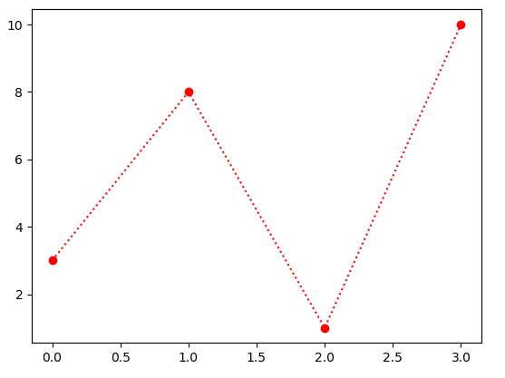
The marker value can be anything from the Marker Reference above.
The line value can be one of the following:
Line Reference

Line Syntax | Description
'-' | Solid line
':' | Dotted line
'--' | Dashed line
'-.' | Dashed/dotted line

The short color value can be one of the following:
Color Reference
Color Syntax | Description
'r' | Red
'g' | Green
'b' | Blue
'c' | Cyan
'm' | Magenta
'y' | Yellow
'k' | Black
'w' | White

Marker Size
You can use the keyword argument markersize or the shorter version, ms to set the size of the markers:
Example
Set the size of the markers to 20:
import matplotlib.pyplot as plt
import numpy as np
ypoints = np.array([3, 8, 1, 10])
plt.plot(ypoints, marker = 'o', ms = 20)
plt.show()
Result:
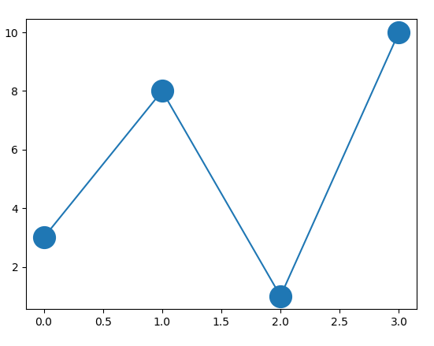
Marker Color
You can use the keyword argument markeredgecolor or the shorter mec to set the color of the edge of the markers:
Example
Set the EDGE color to red:
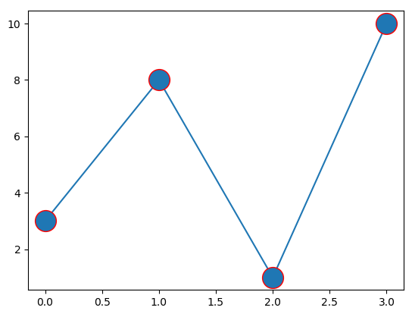
import matplotlib.pyplot as plt
import numpy as np
ypoints = np.array([3, 8, 1, 10])
plt.plot(ypoints, marker = 'o', ms = 20, mec = 'r')
plt.show()
Result:

You can use the keyword argument markerfacecolor or the shorter mfc to set the color inside the edge of the markers:
Example
Set the FACE color to red:
import matplotlib.pyplot as plt
import numpy as np
ypoints = np.array([3, 8, 1, 10])
plt.plot(ypoints, marker = 'o', ms = 20, mfc = 'r')
plt.show()
Result:
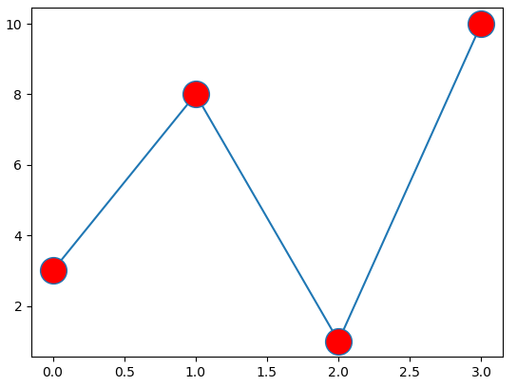
Use both the mec and mfc arguments to color the entire marker:
Example
Set the color of both the edge and the face to red:
import matplotlib.pyplot as plt
import numpy as np
ypoints = np.array([3, 8, 1, 10])
plt.plot(ypoints, marker = 'o', ms = 20, mec = 'r', mfc = 'r')
plt.show()
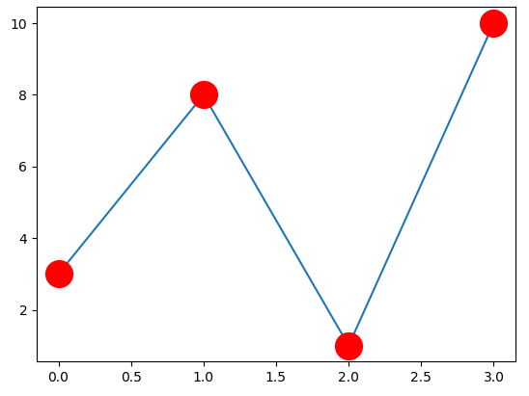
Result:

You can also use Hexadecimal color values:
Example
Mark each point with a beautiful green color:
plt.plot(ypoints, marker = 'o', ms = 20, mec = '#4CAF50', mfc = '#4CAF50')
Result:
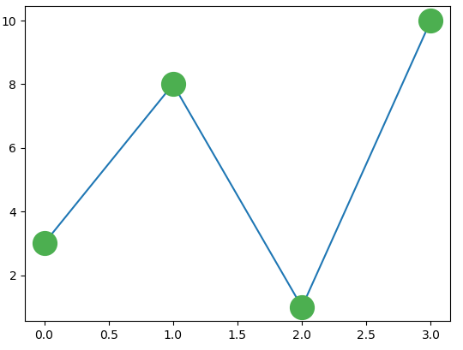
Or any of the 140 supported color names.
Example
Mark each point with the color named "hotpink":
plt.plot(ypoints, marker = 'o', ms = 20, mec = 'hotpink', mfc = 'hotpink')
Result:
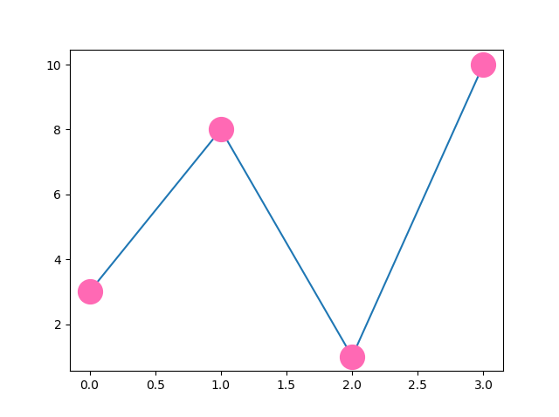

Linestyle
You can use the keyword argument linestyle, or shorter ls, to change the style of the plotted line:
Example
Use a dotted line:
import matplotlib.pyplot as plt
import numpy as np
ypoints = np.array([3, 8, 1, 10])
plt.plot(ypoints, linestyle = 'dotted')
plt.show()
Result:

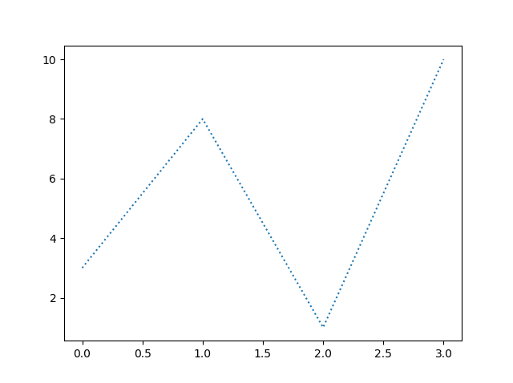
Example
Use a dashed line:
plt.plot(ypoints, linestyle = 'dashed')
Result:
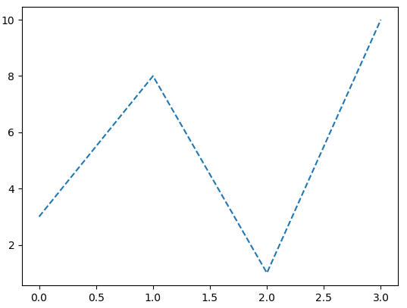

Shorter Syntax
The line style can be written in a shorter syntax:
linestyle can be written as ls.
dotted can be written as :.
dashed can be written as --.
Example
Shorter syntax:
plt.plot(ypoints, ls = ':')
Result:

Line Styles
You can choose any of these styles:
Style | Symbol
'solid' (default) | '-'
'dotted' | ':'
'dashed' | '--'
'dashdot' | '-.'
'None' | '' or ' '

Line Color
You can use the keyword argument color or the shorter c to set the color of the line:
Example:
Set the line color to red:
import matplotlib.pyplot as plt
import numpy as np
ypoints = np.array([3, 8, 1, 10])
plt.plot(ypoints, color = 'r')
plt.show()
Result:
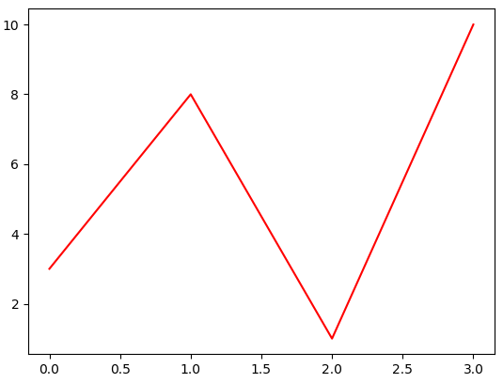
You can also use Hexadecimal color values:
Example
Plot with a beautiful green line:
plt.plot(ypoints, c = '#4CAF50')
Result:
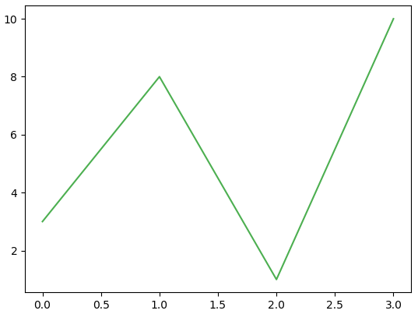

Or any of the 140 supported color names.
Example
Plot with the color named "hotpink":
plt.plot(ypoints, c = 'hotpink')
Result:
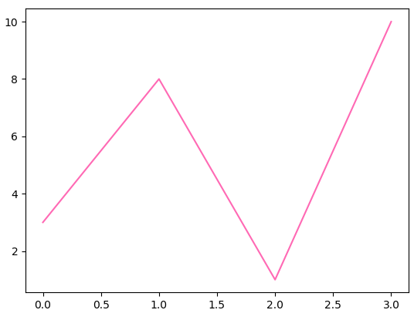

Line Width
You can use the keyword argument linewidth or the shorter lw to change the width of the line.
The value is a floating number, in points:
Example
Plot with a 20.5pt wide line:
import matplotlib.pyplot as plt
import numpy as np
ypoints = np.array([3, 8, 1, 10])
plt.plot(ypoints, linewidth = '20.5')
plt.show()
Result:
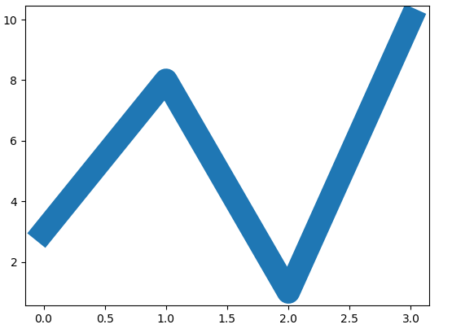

Multiple Lines
You can plot as many lines as you like by simply adding more plt.plot() functions:
Example
Draw two lines by specifying a plt.plot() function for each line:
import matplotlib.pyplot as plt
import numpy as np
y1 = np.array([3, 8, 1, 10])
y2 = np.array([6, 2, 7, 11])
plt.plot(y1)
plt.plot(y2)
plt.show()
Result:
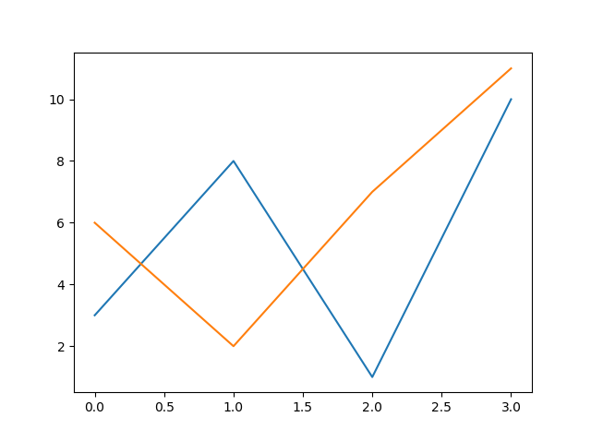
You can also plot many lines by adding the points for the x- and y-axis for each line in the same plt.plot() function.
(In the examples above we only specified the points on the y-axis, meaning that the points on the x-axis got the the default values (0, 1, 2, 3).)
The x- and y- values come in pairs:

Example
Draw two lines by specifiyng the x- and y-point values for both lines:
import matplotlib.pyplot as plt
import numpy as np
x1 = np.array([0, 1, 2, 3])
y1 = np.array([3, 8, 1, 10])
x2 = np.array([0, 1, 2, 3])
y2 = np.array([6, 2, 7, 11])
plt.plot(x1, y1, x2, y2)
plt.show()
Result:

Create Labels for a Plot
With Pyplot, you can use the xlabel() and ylabel() functions to set a label for the x- and y-axis.
Example
Add labels to the x- and y-axis:
import numpy as np
import matplotlib.pyplot as plt
x = np.array([80, 85, 90, 95, 100, 105, 110, 115, 120, 125])
y = np.array([240, 250, 260, 270, 280, 290, 300, 310, 320, 330])
plt.plot(x, y)
plt.xlabel("Average Pulse")
plt.ylabel("Calorie Burnage")
plt.show()
Result:
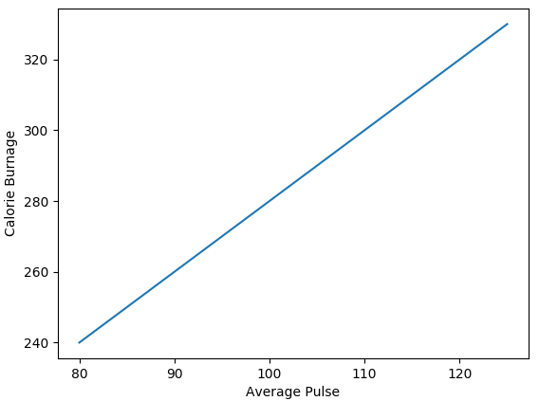

Create a Title for a Plot
With Pyplot, you can use the title() function to set a title for the plot.
Example
Add a plot title and labels for the x- and y-axis:
import numpy as np
import matplotlib.pyplot as plt
x = np.array([80, 85, 90, 95, 100, 105, 110, 115, 120, 125])
y = np.array([240, 250, 260, 270, 280, 290, 300, 310, 320, 330])
plt.plot(x, y)
plt.title("Sports Watch Data")
plt.xlabel("Average Pulse")
plt.ylabel("Calorie Burnage")
plt.show()

Result:
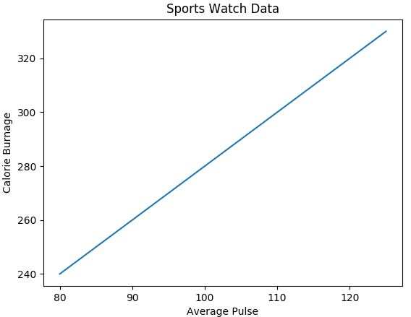

Set Font Properties for Title and Labels
You can use the fontdict parameter in xlabel(), ylabel(), and title() to set font properties for the title and labels.
Example
Set font properties for the title and labels:
import numpy as np
import matplotlib.pyplot as plt
x = np.array([80, 85, 90, 95, 100, 105, 110, 115, 120, 125])
y = np.array([240, 250, 260, 270, 280, 290, 300, 310, 320, 330])
font1 = {'family':'serif','color':'blue','size':20}
font2 = {'family':'serif','color':'darkred','size':15}
plt.title("Sports Watch Data", fontdict = font1)
plt.xlabel("Average Pulse", fontdict = font2)
plt.ylabel("Calorie Burnage", fontdict = font2)
plt.plot(x, y)
plt.show()
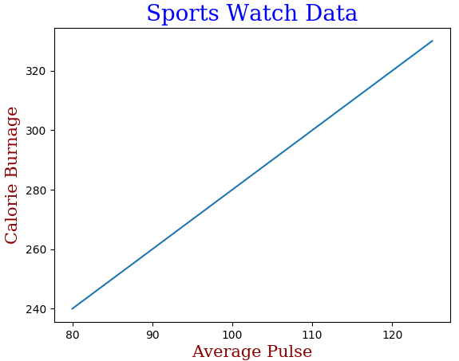
Result:

Position the Title
You can use the loc parameter in title() to position the title.
Legal values are: 'left', 'right', and 'center'. Default value is 'center'.
Example
Position the title to the left:
import numpy as np
import matplotlib.pyplot as plt
x = np.array([80, 85, 90, 95, 100, 105, 110, 115, 120, 125])
y = np.array([240, 250, 260, 270, 280, 290, 300, 310, 320, 330])
plt.title("Sports Watch Data", loc = 'left')
plt.xlabel("Average Pulse")
plt.ylabel("Calorie Burnage")
plt.plot(x, y)
plt.show()
Result:
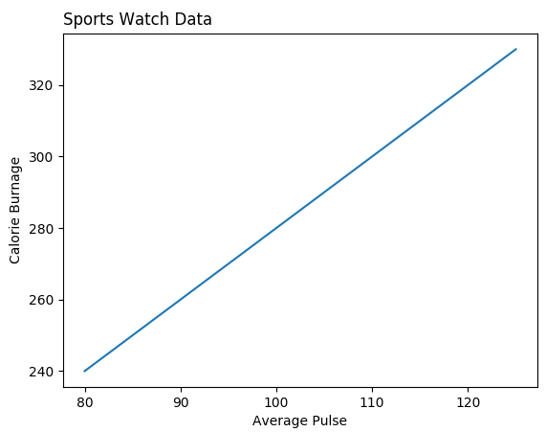

Grid Lines to a Plot
With Pyplot, you can use the grid() function to add grid lines to the plot.
Example
Add grid lines to the plot:
import numpy as np
import matplotlib.pyplot as plt
x = np.array([80, 85, 90, 95, 100, 105, 110, 115, 120, 125])
y = np.array([240, 250, 260, 270, 280, 290, 300, 310, 320, 330])
plt.title("Sports Watch Data")
plt.xlabel("Average Pulse")
plt.ylabel("Calorie Burnage")
plt.plot(x, y)
plt.grid()
plt.show()
Result:
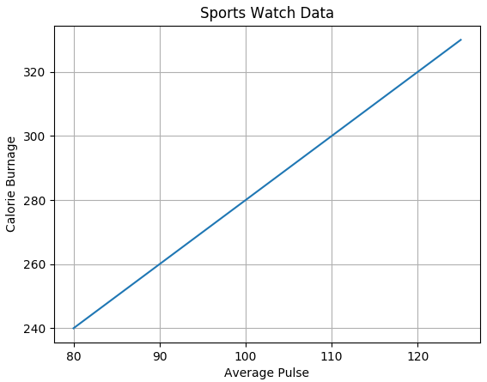

Specify Which Grid Lines to Display
You can use the axis parameter in the grid() function to specify which grid lines to display.
Legal values are: 'x', 'y', and 'both'. Default value is 'both'.
Example
Display only grid lines for the x-axis:
import numpy as np
import matplotlib.pyplot as plt
x = np.array([80, 85, 90, 95, 100, 105, 110, 115, 120, 125])
y = np.array([240, 250, 260, 270, 280, 290, 300, 310, 320, 330])
plt.title("Sports Watch Data")
plt.xlabel("Average Pulse")
plt.ylabel("Calorie Burnage")
plt.plot(x, y)
plt.grid(axis = 'x')
plt.show()
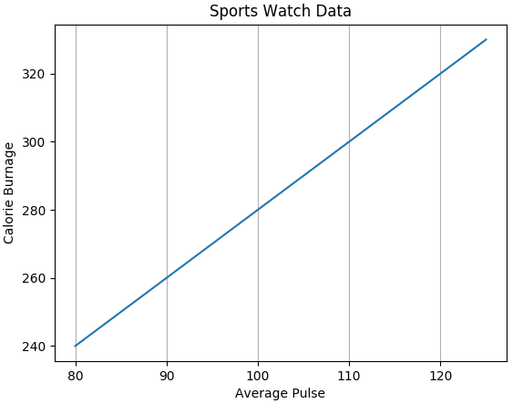
Result:

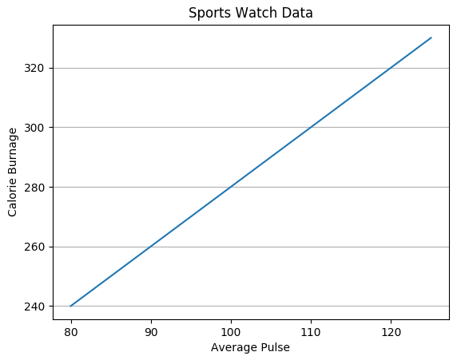
Result:
Example
Display only grid lines for the y-axis:
import numpy as np
import matplotlib.pyplot as plt
x = np.array([80, 85, 90, 95, 100, 105, 110, 115, 120, 125])
y = np.array([240, 250, 260, 270, 280, 290, 300, 310, 320, 330])
plt.title("Sports Watch Data")
plt.xlabel("Average Pulse")
plt.ylabel("Calorie Burnage")
plt.plot(x, y)
plt.grid(axis = 'y')
plt.show()
Set Line Properties for the Grid
You can also set the line properties of the grid, like this: grid(color = 'color', linestyle = 'linestyle', linewidth = number).
Example
Set the line properties of the grid:
import numpy as np
import matplotlib.pyplot as plt
x = np.array([80, 85, 90, 95, 100, 105, 110, 115, 120, 125])
y = np.array([240, 250, 260, 270, 280, 290, 300, 310, 320, 330])
plt.title("Sports Watch Data")
plt.xlabel("Average Pulse")
plt.ylabel("Calorie Burnage")
plt.plot(x, y)
plt.grid(color = 'green', linestyle = '--', linewidth = 0.5)
plt.show()
Result:
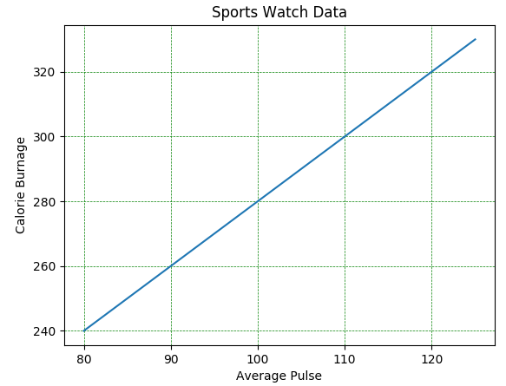

Display Multiple Plots
With the subplot() function you can draw multiple plots in one figure:
Example
Draw 2 plots:
import matplotlib.pyplot as plt
import numpy as np
#plot 1:
x = np.array([0, 1, 2, 3])
y = np.array([3, 8, 1, 10])
plt.subplot(1, 2, 1)
plt.plot(x,y)
#plot 2:
x = np.array([0, 1, 2, 3])
y = np.array([10, 20, 30, 40])
plt.subplot(1, 2, 2)
plt.plot(x,y)
plt.show()
Result:
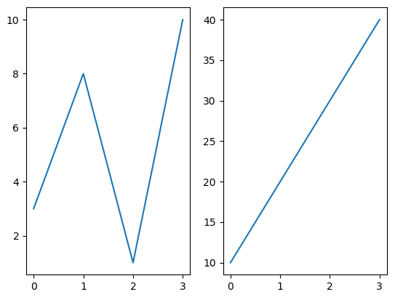

The subplot() Function
The subplot() function takes three arguments that describes the layout of the figure.
The layout is organized in rows and columns, which are represented by the first and second argument.
The third argument represents the index of the current plot.
plt.subplot(1, 2, 1)
#the figure has 1 row, 2 columns, and this plot is the first plot.

plt.subplot(1, 2, 2)
#the figure has 1 row, 2 columns, and this plot is the second plot.
So, if we want a figure with 2 rows an 1 column (meaning that the two plots will be displayed on top of each other instead of side-by-side), we can write the syntax like this:
Example
Draw 2 plots on top of each other:
import matplotlib.pyplot as plt
import numpy as np
#plot 1:
x = np.array([0, 1, 2, 3])
y = np.array([3, 8, 1, 10])
plt.subplot(2, 1, 1)
plt.plot(x,y)
#plot 2:
x = np.array([0, 1, 2, 3])
y = np.array([10, 20, 30, 40])
plt.subplot(2, 1, 2)
plt.plot(x,y)
plt.show()
Result:
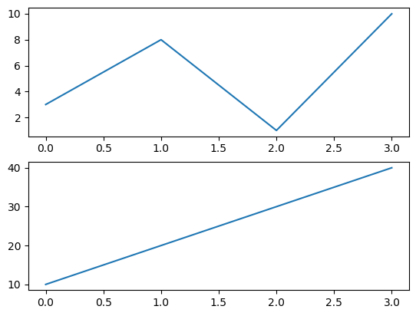
You can draw as many plots you like on one figure, just descibe the number of rows, columns, and the index of the plot.
Example
Draw 6 plots:
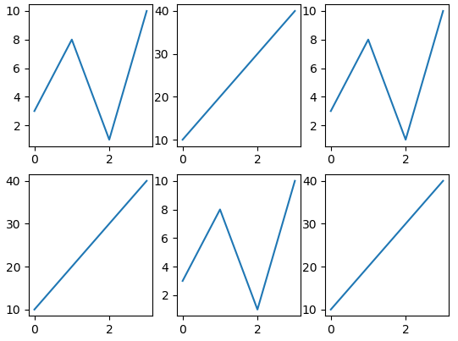
import matplotlib.pyplot as plt
import numpy as np
x = np.array([0, 1, 2, 3])
y = np.array([3, 8, 1, 10])
plt.subplot(2, 3, 1)
plt.plot(x,y)
x = np.array([0, 1, 2, 3])
y = np.array([10, 20, 30, 40])
plt.subplot(2, 3, 2)
plt.plot(x,y)
x = np.array([0, 1, 2, 3])
y = np.array([3, 8, 1, 10])
plt.subplot(2, 3, 3)
plt.plot(x,y)
x = np.array([0, 1, 2, 3])
y = np.array([10, 20, 30, 40])
plt.subplot(2, 3, 4)
plt.plot(x,y)
x = np.array([0, 1, 2, 3])
y = np.array([3, 8, 1, 10])
plt.subplot(2, 3, 5)
plt.plot(x,y)
x = np.array([0, 1, 2, 3])
y = np.array([10, 20, 30, 40])
plt.subplot(2, 3, 6)
plt.plot(x,y)
plt.show()
Result:

Title
You can add a title to each plot with the title() function:
Example
2 plots, with titles:
import matplotlib.pyplot as plt
import numpy as np
#plot 1:
x = np.array([0, 1, 2, 3])
y = np.array([3, 8, 1, 10])
plt.subplot(1, 2, 1)
plt.plot(x,y)
plt.title("SALES")
#plot 2:
x = np.array([0, 1, 2, 3])
y = np.array([10, 20, 30, 40])
plt.subplot(1, 2, 2)
plt.plot(x,y)
plt.title("INCOME")
plt.show()
Result:
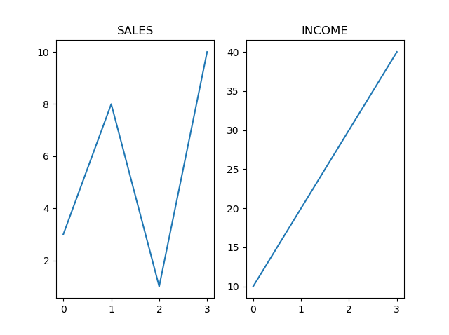
Super Title
You can add a title to the entire figure with the suptitle() function:
Example
Add a title for the entire figure:
import matplotlib.pyplot as plt
import numpy as np
#plot 1:
x = np.array([0, 1, 2, 3])
y = np.array([3, 8, 1, 10])
plt.subplot(1, 2, 1)
plt.plot(x,y)
plt.title("SALES")
#plot 2:
x = np.array([0, 1, 2, 3])
y = np.array([10, 20, 30, 40])
plt.subplot(1, 2, 2)
plt.plot(x,y)
plt.title("INCOME")
plt.suptitle("MY SHOP")
plt.show()
Result:
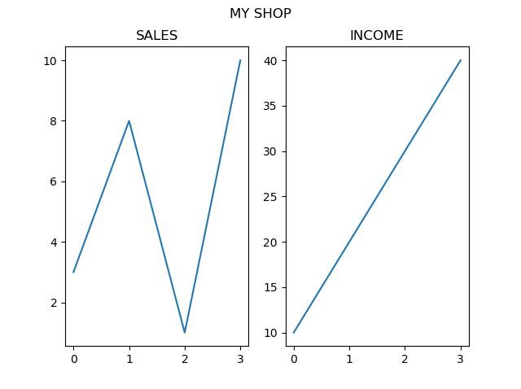
Creating Scatter Plots
With Pyplot, you can use the scatter() function to draw a scatter plot.
The scatter() function plots one dot for each observation. It needs two arrays of the same length, one for the values of the x-axis, and one for values on the y-axis:
Example
A simple scatter plot:
import matplotlib.pyplot as plt
import numpy as np
x = np.array([5,7,8,7,2,17,2,9,4,11,12,9,6])
y = np.array([99,86,87,88,111,86,103,87,94,78,77,85,86])
plt.scatter(x, y)
plt.show()
Result:
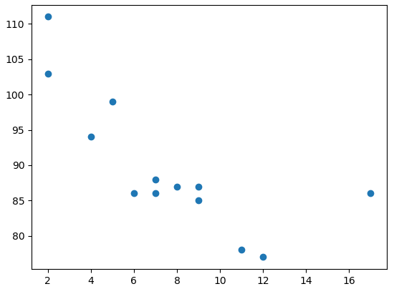
The observation in the example above is the result of 13 cars passing by.
The X-axis shows how old the car is.
The Y-axis shows the speed of the car when it passes.
Are there any relationships between the observations?
It seems that the newer the car, the faster it drives, but that could be a coincidence, after all we only registered 13 cars.

Compare Plots
In the example above, there seems to be a relationship between speed and age, but what if we plot the observations from another day as well? Will the scatter plot tell us something else?

Example
Draw two plots on the same figure:
import matplotlib.pyplot as plt
import numpy as np
#day one, the age and speed of 13 cars:
x = np.array([5,7,8,7,2,17,2,9,4,11,12,9,6])
y = np.array([99,86,87,88,111,86,103,87,94,78,77,85,86])
plt.scatter(x, y)
#day two, the age and speed of 15 cars:
x = np.array([2,2,8,1,15,8,12,9,7,3,11,4,7,14,12])
y = np.array([100,105,84,105,90,99,90,95,94,100,79,112,91,80,85])
plt.scatter(x, y)
plt.show()
Result:
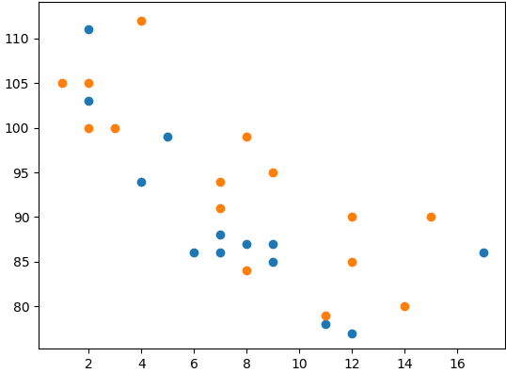
By comparing the two plots, I think it is safe to say that they both gives us the same conclusion: the newer the car, the faster it drives.
Colors
You can set your own color for each scatter plot with the color or the c argument:
Example: Set your own color of the markers:
import matplotlib.pyplot as plt
import numpy as np
x = np.array([5,7,8,7,2,17,2,9,4,11,12,9,6])
y = np.array([99,86,87,88,111,86,103,87,94,78,77,85,86])
plt.scatter(x, y, color = 'hotpink')
x = np.array([2,2,8,1,15,8,12,9,7,3,11,4,7,14,12])
y = np.array([100,105,84,105,90,99,90,95,94,100,79,112,91,80,85])
plt.scatter(x, y, color = '#88c999')
plt.show()
Result:
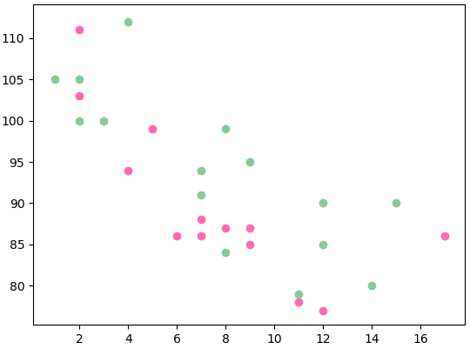

Color Each Dot
You can even set a specific color for each dot by using an array of colors as value for the c argument:
Note: You cannot use the color argument for this, only the c argument.
Example
Set your own color of the markers:
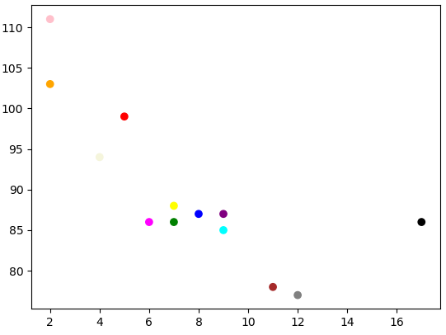
import matplotlib.pyplot as plt
import numpy as np
x = np.array([5,7,8,7,2,17,2,9,4,11,12,9,6])
y = np.array([99,86,87,88,111,86,103,87,94,78,77,85,86])
colors = np.array(["red","green","blue","yellow","pink","black","orange","purple","beige","brown","gray","cyan","magenta"])
plt.scatter(x, y, c=colors)
plt.show()
Result:

ColorMap
The Matplotlib module has a number of available colormaps.
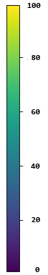
A colormap is like a list of colors, where each color has a value that ranges from 0 to 100.
Here is an example of a colormap:

This colormap is called 'viridis' and as you can see it ranges from 0, which is a purple color, up to 100,
which is a yellow color.
How to Use the ColorMap
You can specify the colormap with the keyword argument cmap with the value of the colormap, in this case 'viridis' which is one of the built-in colormaps available in Matplotlib.
In addition you have to create an array with values (from 0 to 100), one value for each point in the scatter plot:
Example
Create a color array, and specify a colormap in the scatter plot:
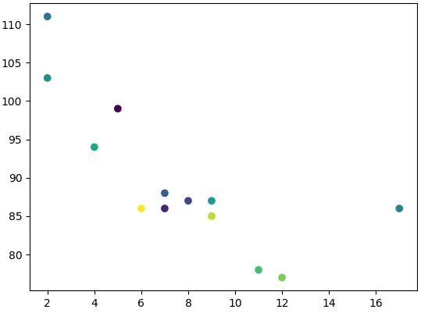
import matplotlib.pyplot as plt
import numpy as np
x = np.array([5,7,8,7,2,17,2,9,4,11,12,9,6])
y = np.array([99,86,87,88,111,86,103,87,94,78,77,85,86])
colors = np.array([0, 10, 20, 30, 40, 45, 50, 55, 60, 70, 80, 90, 100])
plt.scatter(x, y, c=colors, cmap='viridis')
plt.show()
Result:

You can include the colormap in the drawing by including the plt.colorbar() statement:
Example
Include the actual colormap:
import matplotlib.pyplot as plt
import numpy as np
x = np.array([5,7,8,7,2,17,2,9,4,11,12,9,6])
y = np.array([99,86,87,88,111,86,103,87,94,78,77,85,86])
colors = np.array([0, 10, 20, 30, 40, 45, 50, 55, 60, 70, 80, 90, 100])
plt.scatter(x, y, c=colors, cmap='viridis')
plt.colorbar()
plt.show()
Result:
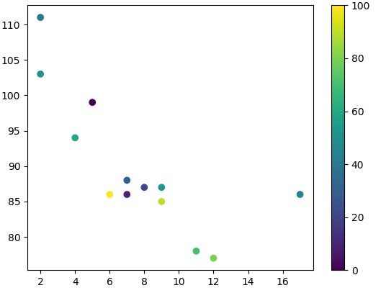
Available ColorMaps
You can choose any of the built-in colormaps:
Name | Reverse
Accent | Accent_r
Blues | Blues_r
BrBG | BrBG_r
BuGn | BuGn_r
BuPu | BuPu_r
CMRmap | CMRmap_r
Dark2 | Dark2_r
GnBu | GnBu_r
Greens | Greens_r
Greys | Greys_r
OrRd | OrRd_r
Oranges | Oranges_r
PRGn | PRGn_r
Paired | Paired_r
Pastel1 | Pastel1_r
Pastel2 | Pastel2_r
PiYG | PiYG_r
PuBu | PuBu_r
PuBuGn | PuBuGn_r
PuOr | PuOr_r
PuRd | PuRd_r
Purples | Purples_r
RdBu | RdBu_r
RdGy | RdGy_r
RdPu | RdPu_r
RdYlBu | RdYlBu_r
RdYlGn | RdYlGn_r
Reds | Reds_r
Set1 | Set1_r
Set2 | Set2_r
Set3 | Set3_r
Spectral | Spectral_r
Wistia | Wistia_r
YlGn | YlGn_r
YlGnBu | YlGnBu_r
YlOrBr | YlOrBr_r
YlOrRd | YlOrRd_r
afmhot | afmhot_r
autumn | autumn_r
binary | binary_r
bone | bone_r
brg | brg_r
bwr | bwr_r
cividis | cividis_r
cool | cool_r
coolwarm | coolwarm_r
copper | copper_r
cubehelix | cubehelix_r
flag | flag_r
gist_earth | gist_earth_r
gist_gray | gist_gray_r
gist_heat | gist_heat_r
gist_ncar | gist_ncar_r
gist_rainbow | gist_rainbow_r
gist_stern | gist_stern_r
gist_yarg | gist_yarg_r
gnuplot | gnuplot_r
gnuplot2 | gnuplot2_r
gray | gray_r
hot | hot_r
hsv | hsv_r
inferno | inferno_r
jet | jet_r
magma | magma_r
nipy_spectral | nipy_spectral_r
ocean | ocean_r
pink | pink_r
plasma | plasma_r
prism | prism_r
rainbow | rainbow_r
seismic | seismic_r
spring | spring_r
summer | summer_r
tab10 | tab10_r
tab20 | tab20_r
tab20b | tab20b_r
tab20c | tab20c_r
terrain | terrain_r
twilight | twilight_r
twilight_shifted | twilight_shifted_r
viridis | viridis_r
winter | winter_r

Size
You can change the size of the dots with the s argument.
Just like colors, make sure the array for sizes has the same length as the arrays for the x- and y-axis:
Example
Set your own size for the markers:
import matplotlib.pyplot as plt
import numpy as np
x = np.array([5,7,8,7,2,17,2,9,4,11,12,9,6])
y = np.array([99,86,87,88,111,86,103,87,94,78,77,85,86])
sizes = np.array([20,50,100,200,500,1000,60,90,10,300,600,800,75])
plt.scatter(x, y, s=sizes)
plt.show()
Result:
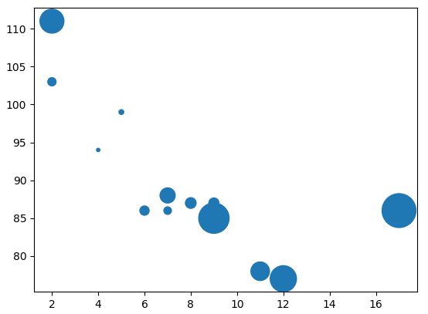

Alpha
You can adjust the transparency of the dots with the alpha argument.
Just like colors, make sure the array for sizes has the same length as the arrays for the x- and y-axis:
Example
Set your own size for the markers:
import matplotlib.pyplot as plt
import numpy as np
x = np.array([5,7,8,7,2,17,2,9,4,11,12,9,6])
y = np.array([99,86,87,88,111,86,103,87,94,78,77,85,86])
sizes = np.array([20,50,100,200,500,1000,60,90,10,300,600,800,75])
plt.scatter(x, y, s=sizes, alpha=0.5)
plt.show()
Result:
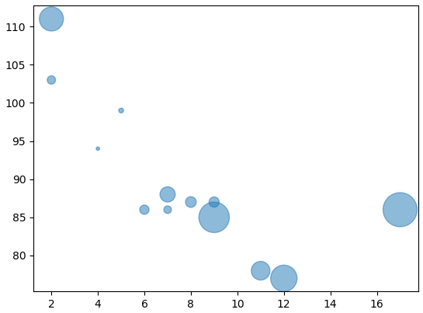
Combine Color Size and Alpha
You can combine a colormap with different sizes of the dots. This is best visualized if the dots are transparent:
Example- Create random arrays with 100 values for x-points, y-points, colors and sizes:
import matplotlib.pyplot as plt
import numpy as np
x = np.random.randint(100, size=(100))
y = np.random.randint(100, size=(100))
colors = np.random.randint(100, size=(100))
sizes = 10 * np.random.randint(100, size=(100))
plt.scatter(x, y, c=colors, s=sizes, alpha=0.5, cmap='nipy_spectral')
plt.colorbar()
plt.show()
Result:
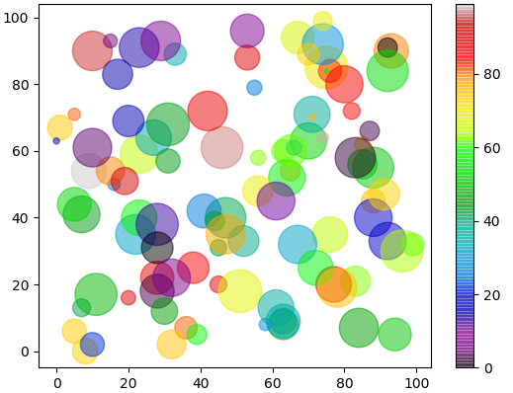
Creating Bars
With Pyplot, you can use the bar() function to draw bar graphs:
Example
Draw 4 bars:
import matplotlib.pyplot as plt
import numpy as np
x = np.array(["A", "B", "C", "D"])
y = np.array([3, 8, 1, 10])
plt.bar(x,y)
plt.show()
Result:
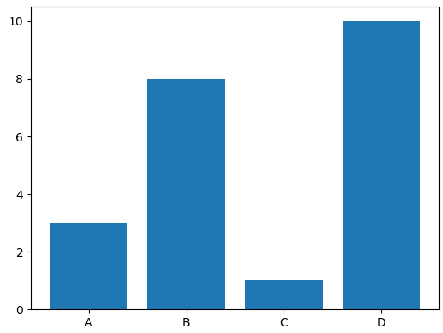
Horizontal Bars
If you want the bars to be displayed horizontally instead of vertically, use the barh() function:
Example
Draw 4 horizontal bars:
import matplotlib.pyplot as plt
import numpy as np
x = np.array(["A", "B", "C", "D"])
y = np.array([3, 8, 1, 10])
plt.barh(x, y)
plt.show()
Result:
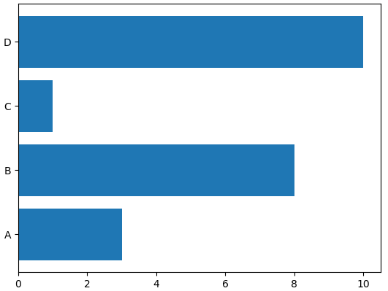

Bar Color
The bar() and barh() take the keyword argument color to set the color of the bars:
Example
Draw 4 red bars:
import matplotlib.pyplot as plt
import numpy as np
x = np.array(["A", "B", "C", "D"])
y = np.array([3, 8, 1, 10])
plt.bar(x, y, color = "red")
plt.show()

Result:
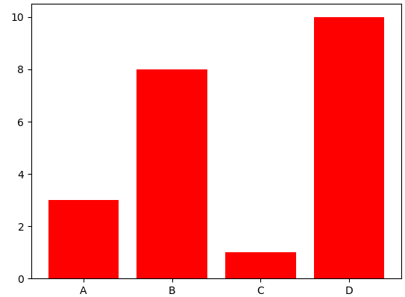
Color Names
Example
Draw 4 "hot pink" bars:
import matplotlib.pyplot as plt
import numpy as np
x = np.array(["A", "B", "C", "D"])
y = np.array([3, 8, 1, 10])
plt.bar(x, y, color = "hotpink")
plt.show()
Result:
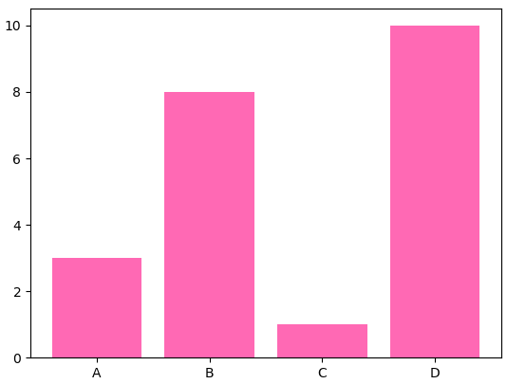
Color Hex
Or you can use Hexadecimal color values:
Example
Draw 4 bars with a beautiful green color:
import matplotlib.pyplot as plt
import numpy as np
x = np.array(["A", "B", "C", "D"])
y = np.array([3, 8, 1, 10])
plt.bar(x, y, color = "#4CAF50")
plt.show()
Result:
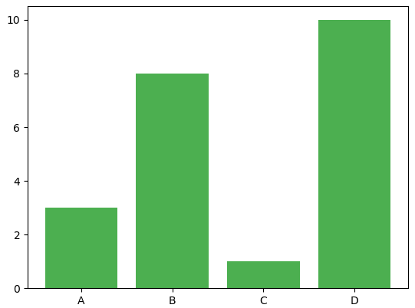

Bar Width
The bar() takes the keyword argument width to set the width of the bars:
Example
Draw 4 very thin bars:
import matplotlib.pyplot as plt
import numpy as np
x = np.array(["A", "B", "C", "D"])
y = np.array([3, 8, 1, 10])
plt.bar(x, y, width = 0.1)
plt.show()
Result:
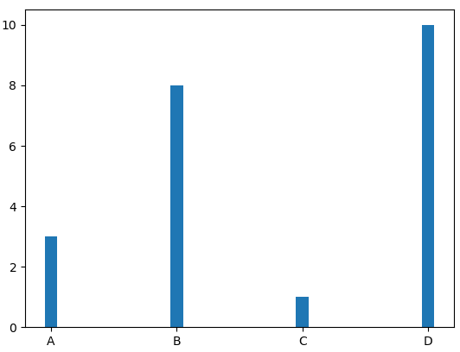
The default width value is 0.8

Bar Height
The barh() takes the keyword argument height to set the height of the bars:
Example
Draw 4 very thin bars:
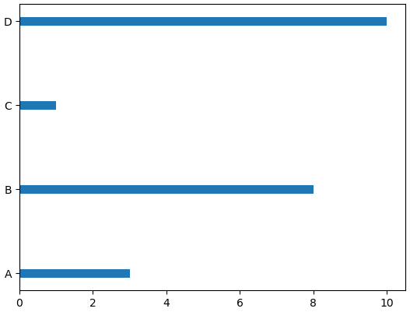
import matplotlib.pyplot as plt
import numpy as np
x = np.array(["A", "B", "C", "D"])
y = np.array([3, 8, 1, 10])
plt.barh(x, y, height = 0.1)
plt.show()
Result:

Histogram
A histogram is a graph showing frequency distributions.
It is a graph showing the number of observations within each given interval.
Example: Say you ask for the height of 250 people, you might end up with a histogram like this:
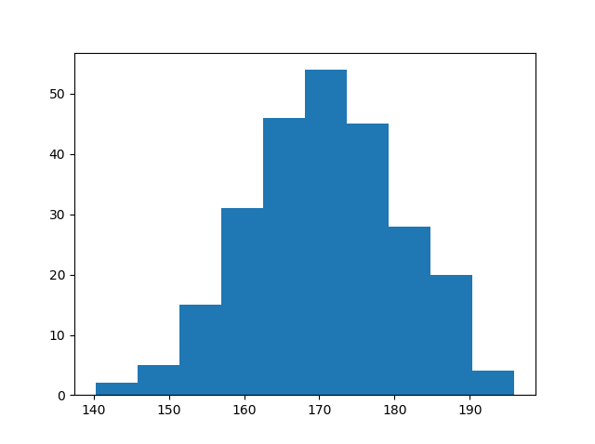
You can read from the histogram that there are approximately:
2 people from 140 to 145cm
5 people from 145 to 150cm
15 people from 151 to 156cm
31 people from 157 to 162cm
46 people from 163 to 168cm
53 people from 168 to 173cm
45 people from 173 to 178cm
28 people from 179 to 184cm
21 people from 185 to 190cm
4 people from 190 to 195cm

Create Histogram
In Matplotlib, we use the hist() function to create histograms.
The hist() function will use an array of numbers to create a histogram, the array is sent into the function as an argument.
For simplicity we use NumPy to randomly generate an array with 250 values, where the values will concentrate around 170, and the standard deviation is 10. Learn more about Normal Data Distribution in our Machine Learning Tutorial.

Example
A Normal Data Distribution by NumPy:
import numpy as np
x = np.random.normal(170, 10, 250)
print(x)
Result:
This will generate a random result

The hist() function will read the array and produce a histogram:
Example
A simple histogram:
import matplotlib.pyplot as plt
import numpy as np
x = np.random.normal(170, 10, 250)
plt.hist(x)
plt.show()
Result:

Creating Pie Charts
With Pyplot, you can use the pie() function to draw pie charts:
Example
A simple pie chart:
import matplotlib.pyplot as plt
import numpy as np
y = np.array([35, 25, 25, 15])
plt.pie(y)
plt.show()
Result:
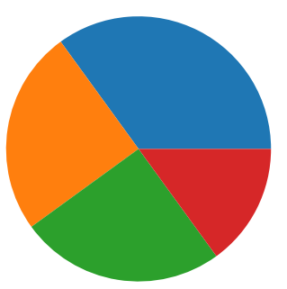
As you can see the pie chart draws one piece (called a wedge) for each value in the array (in this case [35, 25, 25, 15]).
By default the plotting of the first wedge starts from the x-axis and moves counterclockwise:
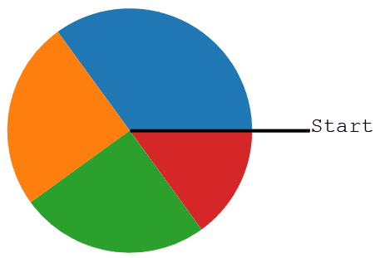
Note: The size of each wedge is determined by comparing the value with all the other values, by using this formula:
The value divided by the sum of all values: x/sum(x)
Labels
Add labels to the pie chart with the labels parameter.
The labels parameter must be an array with one label for each wedge:
Example
A simple pie chart:
import matplotlib.pyplot as plt
import numpy as np
y = np.array([35, 25, 25, 15])
mylabels = ["Apples", "Bananas", "Cherries", "Dates"]
plt.pie(y, labels = mylabels)
plt.show()
Result:
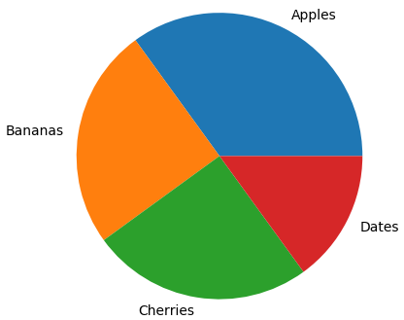

Start Angle
As mentioned the default start angle is at the x-axis, but you can change the start angle by specifying a startangle parameter.
The startangle parameter is defined with an angle in degrees, default angle is 0:
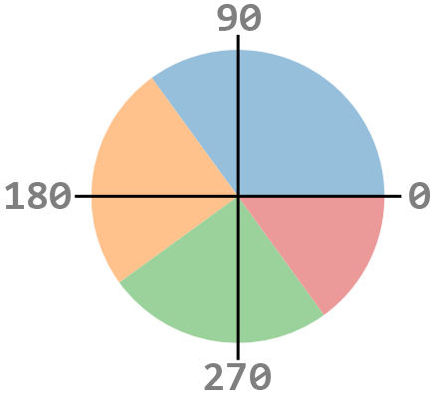
Example
Start the first wedge at 90 degrees:
import matplotlib.pyplot as plt
import numpy as np
y = np.array([35, 25, 25, 15])
mylabels = ["Apples", "Bananas", "Cherries", "Dates"]
plt.pie(y, labels = mylabels, startangle = 90)
plt.show()
Result:
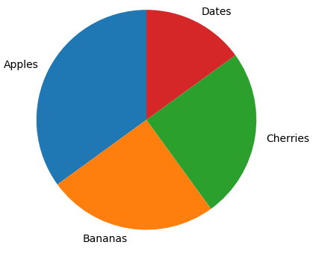

Explode
Maybe you want one of the wedges to stand out? The explode parameter allows you to do that.
The explode parameter, if specified, and not None, must be an array with one value for each wedge.
Each value represents how far from the center each wedge is displayed:
Example
Pull the "Apples" wedge 0.2 from the center of the pie:
import matplotlib.pyplot as plt
import numpy as np
y = np.array([35, 25, 25, 15])
mylabels = ["Apples", "Bananas", "Cherries", "Dates"]
myexplode = [0.2, 0, 0, 0]
plt.pie(y, labels = mylabels, explode = myexplode)
plt.show()

Result:
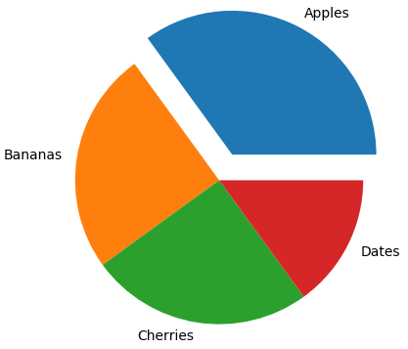

Shadow
Add a shadow to the pie chart by setting the shadows parameter to True:
Example
Add a shadow:
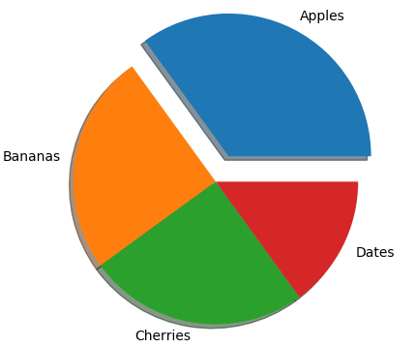
import matplotlib.pyplot as plt
import numpy as np
y = np.array([35, 25, 25, 15])
mylabels = ["Apples", "Bananas", "Cherries", "Dates"]
myexplode = [0.2, 0, 0, 0]
plt.pie(y, labels = mylabels, explode = myexplode, shadow = True)
plt.show()
Result:

Colors
You can set the color of each wedge with the colors parameter.
The colors parameter, if specified, must be an array with one value for each wedge:
Example
Specify a new color for each wedge:
import matplotlib.pyplot as plt
import numpy as np
y = np.array([35, 25, 25, 15])
mylabels = ["Apples", "Bananas", "Cherries", "Dates"]
mycolors = ["black", "hotpink", "b", "#4CAF50"]
plt.pie(y, labels = mylabels, colors = mycolors)
plt.show()
Result:
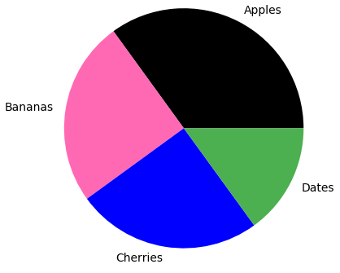
You can use Hexadecimal color values, any of the 140 supported color names, or one of these shortcuts:
'r' - Red
'g' - Green
'b' - Blue
'c' - Cyan
'm' - Magenta
'y' - Yellow
'k' - Black
'w' - White

Legend
To add a list of explanation for each wedge, use the legend() function:
Example
Add a legend:
import matplotlib.pyplot as plt
import numpy as np
y = np.array([35, 25, 25, 15])
mylabels = ["Apples", "Bananas", "Cherries", "Dates"]
plt.pie(y, labels = mylabels)
plt.legend()
plt.show()
Result:
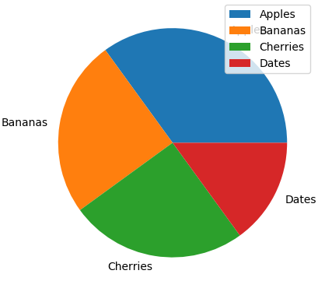
Legend With Header
To add a header to the legend, add the title parameter to the legend function.
Example
Add a legend with a header:
import matplotlib.pyplot as plt
import numpy as np
y = np.array([35, 25, 25, 15])
mylabels = ["Apples", "Bananas", "Cherries", "Dates"]
plt.pie(y, labels = mylabels)
plt.legend(title = "Four Fruits:")
plt.show()

Result:
